TITLE | Naive Bayes algorithm for classification on Pima Indians Diabetes dataset.
PROBLEM STATEMENT / DEFINITION | Download Pima Indians Diabetes dataset. Use Naive Bayes Algorithm for classification  - Load the data from CSV file and split it into training and test datasets.  - summarize the properties in the training dataset so that we can calculate probabilities and make predictions.  - Classify samples from a test dataset and a summarized training dataset.
OBJECTIVE | - Learn Naive Bayes algorithm  - Learn to use Naive Bayes algorithm for classification on given dataset
S/W PACKAGES AND  HARDWARE APPARATUS USED | - Operating System : 64-bit Open source Linux or its derivative  - Programming Languages: PYTHON/R
REFERENCES | - Mark Gardner, “Beginning R: The Statistical Programming Language”, Wrox Publication, ISBN: 978-1-118-16430-3  - David Dietrich, Barry Hiller, “Data Science and Big Data Analytics”, EMC education services, Wiley publications, 2012, ISBN0-07-120413-X  - Luis Torgo, “Data Mining with R, Learning with Case Studies”, CRC Press, Talay and Francis Group, ISBN9781482234893
STEPS | Refer to theory
INSTRUCTIONS FOR  WRITING JOURNAL | - Date  - Assignment no.  - Problem definition  - Learning objective  - Learning outcome  - Related Mathematics  - Concepts related Theory  - Test cases  - Program code with proper documentation.  - Output of program.  - Conclusion and applications (the verification and testing of outcomes)

Assignment No. A2

- Aim:
Naive Bayes algorithm for classification on Pima Indians Diabetes dataset.
- Problem Statement / Definition:
- Download Pima Indians Diabetes dataset. Use Naive Bayes Algorithm for classification
- Load the data from CSV file and split it into training and test datasets.
- summarize the properties in the training dataset so that we can calculate probabilities and make predictions.
- Classify samples from a test dataset and a summarized training dataset.

- Prerequisites
Database management system, Python/R programming

- Learning Objectives
- Learn Naive Bayes algorithm
- Learn to summarize the properties in the training dataset.
- Learn to split dataset into training and test datasets
- Learn to classify samples from a test dataset and a summarized training dataset.

- Learning Outcome:
Students will be able to summarize the properties of dataset, split dataset into training and test data, apply Naive Bayes algorithm for classification application.

- Related Mathematics
Mathematical Model
Let S be the system set:
S = {s; e;X; Y; Fme;DD;NDD; Fc; Sc} where Dataset is loaded into the dataframe
s=start state
e=end state i.e. classification of samples from the test dataset
X=set of inputs
X = {X1}
where
X1 = Pima Indians Diabetes dataset
where ,
Y=set of outputs
1) Splitting of dataset into training and test datasets
2) Naive Bayes classifier

Fme is the set of main functions
Fme = {f1,f2,f3}
where
f1 = function to load dataset into dataframe
f2 = function to split dataset into training and test datasets
f3 = function to invoke Naive Bayes classifier
DD= Deterministic Data
PIMA Indians diabetes dataset
NDD=Non-deterministic data
null values in the dataset
Fc =failure case:
Failed to classify the record into correct class

- Theory:
The Bayesian Classification represents a supervised learning method as well as a statistical method for classification. Assumes an underlying probabilistic model and it allows us to capture uncertainty about the model in a principled way by determining probabilities of the outcomes. It can solve diagnostic and predictive problems. This Classification is named after Thomas Bayes, who proposed the Bayes Theorem. Bayesian classification provides practical learning algorithms and prior knowledge and observed data can be combined. Bayesian Classification provides a useful perspective for understanding and evaluating many learning algorithms. It calculates explicit probabilities for hypothesis and it is robust to noise in input data.
Example
Consider a weather dataset in figure 1.
Consider a fictional dataset that describes the weather conditions for playing a game of golf. Given the weather conditions, each tuple classifies the conditions as fit(“Yes”) or unfit(“No”) for playing golf.
The dataset is shown in figure 1. The dataset is divided into two parts, namely, feature matrix and the response vector.
- Feature matrix contains all the vectors(rows) of dataset in which each vector consists of the value of dependent features. In above dataset, features are ‘Outlook’, ‘Temperature’, ‘Humidity’ and ‘Windy’.
- Response vector contains the value of class variable(prediction or output) for each row of feature matrix. In above dataset, the class variable name is ‘Play golf’.

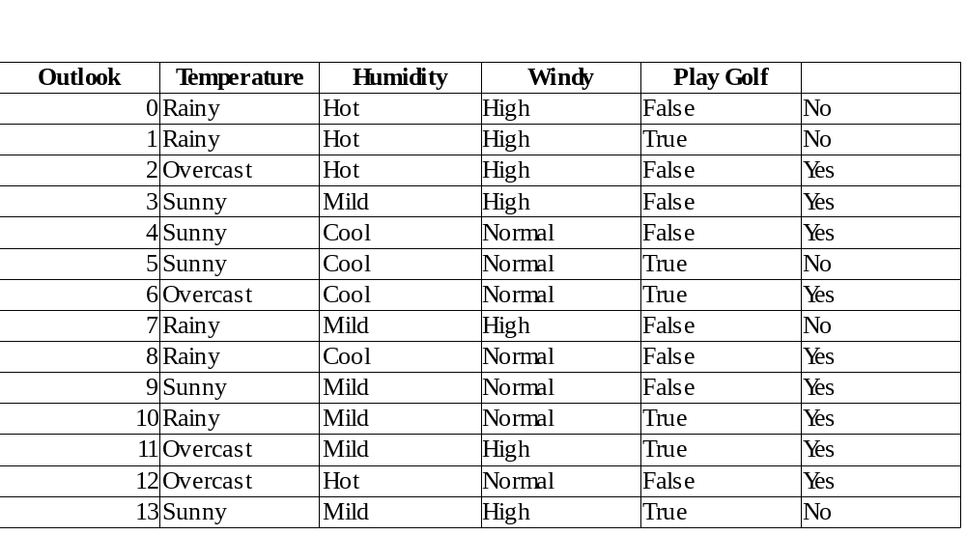

Figure 1

Assumption:
The fundamental Naive Bayes assumption is that each feature makes an:
- independent
- equal
contribution to the outcome.
With relation to dataset, this concept can be understood as:
- Assume that no pair of features are dependent. For example, the temperature being ‘Hot’ has nothing to do with the humidity or the outlook being ‘Rainy’ has no effect on the winds. Hence, the features are assumed to be independent.
- Secondly, each feature is given the same weight(or importance). For example, knowing only temperature and humidity alone can’t predict the outcome accuratey. None of the attributes is irrelevant and assumed to be contributing equally to the outcome.
Bayes’ Theorem
Bayes’ Theorem finds the probability of an event occurring given the probability of another event that has already occurred. Bayes’ theorem is stated mathematically as the following equation:

where A and B are events and P(B) ?
- Basically, we are trying to find probability of event A, given the event B is true. Event B is also termed as evidence.
- P(A) is the priori of A (the prior probability, i.e. Probability of event before evidence is seen). The evidence is an attribute value of an unknown instance(here, it is event B).
- P(A|B) is a posteriori probability of B, i.e. probability of event after evidence is seen.
Now, with regards to our dataset, we can apply Bayes’ theorem in following way:

where, y is class variable and X is a dependent feature vector (of size n) where:

X = (Rainy, Hot, High, False)
y = No
So P(X|y) means, the probability of “Not playing golf” given that the weather conditions are “Rainy
outlook”, “Temperature is hot”, “high humidity” and “no wind”.
Naive assumption
Now, its time to put a naive assumption to the Bayes’ theorem, which is, independence among the features. So now, we split evidence into the independent parts.
Now, if any two events A and B are independent, then,
P(A,B) = P(A)P(B)
Hence, we reach to the result:

which can be expressed as:

Now, as the denominator remains constant for a given input, we can remove that term:

Now, create a classifier model. For this, we find the probability of given set of inputs for all possible values of the class variable y and pick up the output with maximum probability. This can be expressed mathematically as:

Now calculate P(y) and P(xi | y).
P(y) is also called class probability and P(xi | y) is called conditional probability.
The different naive Bayes classifiers differ mainly by the assumptions they make regarding the distribution of P(xi | y).
Now apply the above formula on weather dataset.
Find P(xi | yj) for each xi in X and yj in y.
So, in the figure 1 above, calculate P(xi | yj) for each xi in X and yj in y. For example, probability of playing golf given that the temperature is cool, i.e P(temp. = cool | play golf = Yes) = 3/9.
Also, find class probabilities (P(y)). For example, P(play golf = Yes) = 9/14.
So now the classifier is ready!
Now test it on a new set of features (let us call it today):
today = (Sunny, Hot, Normal, False)
So, probability of playing golf is given by:
and probability to not play golf is given by:

Since, P(today) is common in both probabilities, it can be ignored and find proportional probabilities as:

P(Yes|today) ∝ 2/9 ⋅ 2/9 ⋅ 6/9 ⋅ 6/9 ⋅ 9/14 ≃ 0.0141

And
P(No|today) ∝ 3/5 ⋅ 2/5 ⋅ 1/5 ⋅ 2/5 ⋅ 5/14 ≃ 0.0068

Now, since
P(Yes|today) + P(No|today) =1

These numbers can be converted into a probability by making the sum equal to 1 (normalization):

and

Since
So, prediction that golf would be played is ‘Yes’.
The method is applicable for discrete data. In case of continuous data, need to make some assumptions regarding the distribution of values of each feature. The different naive Bayes classifiers differ mainly by the assumptions they make regarding the distribution of P(xi | y).
Gaussian Naive Bayes classifier
In Gaussian Naive Bayes, continuous values associated with each feature are assumed to be distributed according to a Gaussian distribution. A Gaussian distribution is also called Normal distribution. When plotted, it gives a bell shaped curve which is symmetric about the mean of the feature values as shown below in figure 2:

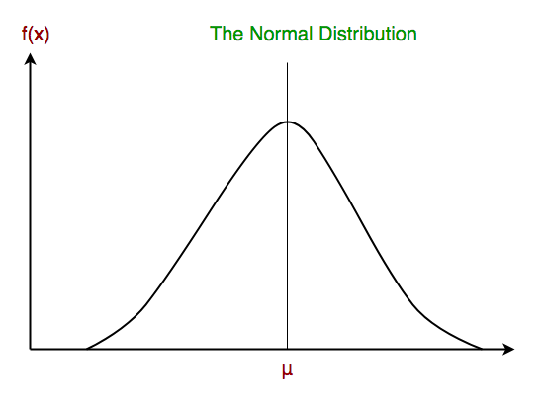

Figure 2.

The likelihood of the features is assumed to be Gaussian, hence, conditional probability is given by:

Other popular Naive Bayes classifiers are:
- Multinomial Naive Bayes: Feature vectors represent the frequencies with which certain events have been generated by a multinomial distribution. This is the event model typically used for document classification.
- Bernoulli Naive Bayes: In the multivariate Bernoulli event model, features are independent booleans (binary variables) describing inputs. Like the multinomial model, this model is popular for document classification tasks, where binary term occurrence(i.e. a word occurs in a document or not) features are used rather than term frequencies(i.e. frequency of a word in the document).
R commands:
Commands to include necessary libraries:
library(caret)

library("e1071")
library(klaR)

library(GGally)

- Command to split dataset into training and test data:
labels<-allData[,#col] #labels
To partition the data (80% training, 20% testing)
trainingData <- createDataPartition(y=labels, p=.8, list=FALSE)

- Command to use a Naive Bayes model for the classifier ('nb'):

classifierModel <- train(trainingFeatures, trainingLabels, 'nb',
trControl = trainControl(method='cv', number=10))

- Test data:
Pima Indians Diabetes dataset

